No child left behind!
Teacher Conference
Boosting the Inclusive
Quality of Your Lessons

A whole day workshop for teachers on:
- Creating the right classroom climate
- Identifying and meeting specific learning needs
- Supporting students with weak working memory
- Tracking your quick thinking, slow delivering students
- Self-directed learning
- Supporting students with low confidence and self-esteem issues
- Boosting decoding and analytical skills
- Strengthening comprehension activities
- Getting reluctant writers to show what they know

Course date: Tuesday 27th February 9.30 – 3.30 pm
Venue: PLC1, Valence School, Westerham TN16 1QN
Neil MacKay:
An independent international educational consultant and trainer who helps teachers and schools implement Quality First Teaching within a context of self-evaluation, inspection and personalisation of learning.

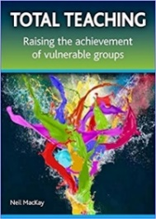
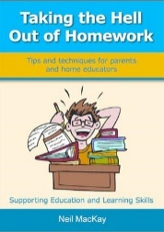
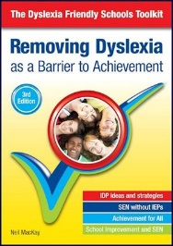
Author of:

Cost: £60 Earlybird Cost: £50 (payable by 31st Jan)

Book early to avoid disappointment!

Refreshments provided - Please bring your own lunch as this is not provided

